Source#1
NEWS IN BRIEF
Closing Of State Aviary Facilities Puts Hundreds Of Mentally Ill Birds On The Streets

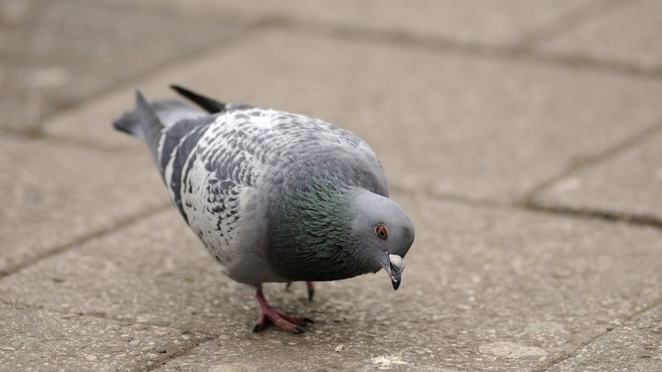

PROVIDENCE, RI—Due to budgetary constraints, the State of Rhode Island was forced to shutter a number of its aviary facilities Sunday, resulting in hundreds of mentally ill sparrows, pigeons, chickadees, pelicans, kestrels, and penguins being put out on the street. "These birds are incapable of making the decisions necessary to navigate through everyday life," Providence Aviary administrator Margaret Lyons said as a disturbed grackle pecked at a spot on the ground where there was clearly no food. "With nowhere to go and no one to look after them, they roam the streets, sleep on telephone wires, and fly uncontrollably and repeatedly into large-frame plate-glass windows. Frankly, it's irresponsible and inhumane to release a kiwi that hears voices into a world where it could be a danger to itself or to others." Gov. Lincoln Chafee has promised swift action, stating that he would close the state's cat shelters in order to rectify the situation.

Read Source #1. Is this story credible? Decide whether or not this story can be trusted. Cite evidence and explain your answer. R.A.C.E.
________________________________________________________________________________________________________________________________________________________________________________________________________________________________________________________________________________________________________________________________________________________________________________________________________________________________________________________________________________________________________________________________________________________________________________________________

Source #2

Volunteers Needed for ‘Funny-Looking’ Bird Study
March 14, 2018
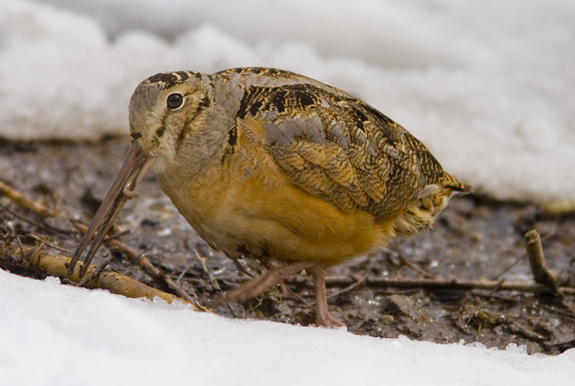

TODD McLEISH/ecoRI News contributor
One of the region’s most unusual birds is the subject of a research project by University of Rhode Island doctoral student Erin Harrington, and she’s seeking at least 80 volunteers to become citizen scientists to contribute to her work. All it takes is a commitment of 38 minutes at dusk on four dates between April 20 and May 10, plus attendance at a two-hour training session.
The subject of Harrington’s study is the American timberdoodle, which she calls “a funny-looking bird with short, stubby legs and a variety of silly nicknames that makes arguably the silliest sounding mating call known to mankind.” She’s not kidding.
“They’re an ideal bird for citizen scientists to work with because they’re unique and goofy looking, but their goofiness is endearing in a way that makes them distinctive and easy to identify,” Harrington said.
The timberdoodles are chunky, brownish birds with large eyes, short tails, and long beaks that they probe into the ground in search of earthworms to eat. They are found throughout the eastern United States, but their populations have been declining throughout their range. Little is known about their habits and habitat preferences in Rhode Island.
- Read Source #2. Is this story credible? Why or why not? Cite evidence to support your answer then explain your reasoning.
________________________________________________________________________________________________________________________________________________________________________________________________________________________________________________________________________________________________________________________________________________________________________________________________________________________________________________________________________________________________________________________________________________________________________________________________

