10 Outrageous Real Life Superheroes
Article of the Week #4 Due Friday 9/19
Name:
Period:
ANDREW HANDLEY MARCH 24, 2013
On this side, write a summary for each section.
On this side, write any questions or comments you might have.
All of us have an innate urge deep inside that makes us want to do good for the people around us, and while some of us are content to read about the super powered good deeds of others, the people on this list decided to stand up and show the world that crime does not pay. Unfortunately, they chose a route that looks absolutely, thoroughly ridiculous. Here are real life superheroes who could be behind you right now.
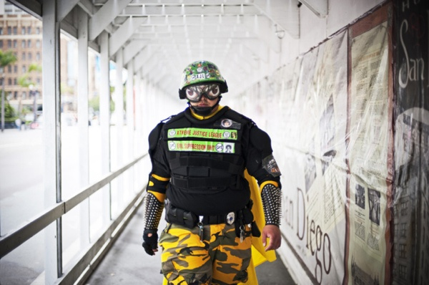

Mr. Extreme
Secret Identity: Secret!
Personal Gotham: San Diego, California
Honestly, if there’s any city that needs a superhero it’s probably San Diego, especially after the police department was downsized in 2012, leading to an increase in crime. And Mr. Extreme might not be the hero San Diego deserves, but he’s the hero San Diego puts up with. A security guard in the daylight hours, once the sun goes down he suits up with shin guards, cape, army helmet and identity-protection goggles, then vigorously strolls into the crime-ridden sidewalks of the East Village.Mr. Extreme has been working for about seven years now, armed with a taser, handcuffs, three cans of pepper spray, and the conviction that right is always the right thing to do. While he doesn’t get into a whole lot of action, he has instigated several citizens arrests throughout his career.
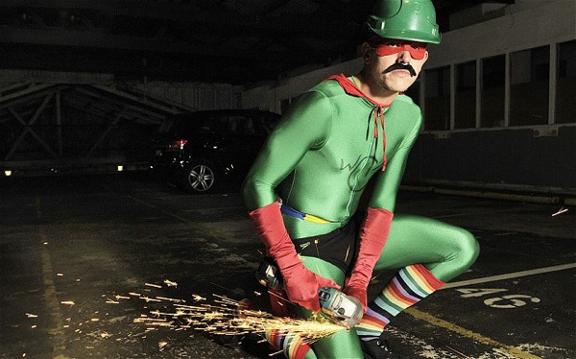

Wheel Clamp Man
Identity: Secret!
Personal Gotham: Perth, Australia
The path of a hero is never black and white. It’s an uncertain world filled with lesser evils and shades of gray, because sometimes the duty of a man requires him to go outside the law to prevent a crime. Or commit one. This is the path of Wheel Clamp Man, one of the darker shades of gray in the colorblind spectrum. In fact, his main “heroic” activity is a full-fledged crime—he patrols Perth with an angle grinder and cuts wheel clamps off cars that have been illegally parked.Dressed in a skintight green leotard, rainbow socks, and a glue-on mustache, Wheel Clamp Man has only been working in the area for a relatively short time, but motorists are grateful for his help in helping them avoid a $135 fine.
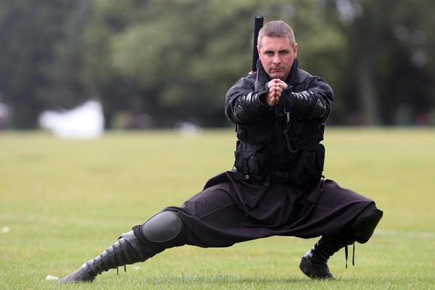

Shadow
Secret Identity: Ken Andre
Personal Gotham: Yeovil, Somerset, UK
Eschewing the pomp and flash of a typical superhero costume, 33 year old Ken Andre took a different approach to vigilante justice: the way of the ninja. He calls himself Shadow and spends up to four nights a week out around his home in Somerset stopping drug dealers and muggers—in the few years he’s been doing this, he says he’s stopped several dozen crimes. And out of all the people on this list, Shadow is the only real life superhero with anything even resembling a super power—a Batman-esque hearing aid that amplifies sound. Ken has been studying the martial art Ninjutsu since he was a child, and stopped a carjacker one time by literally throwing nunchucks at him. In his own words, “I tied him to the lamppost using his own legs and called the police.”
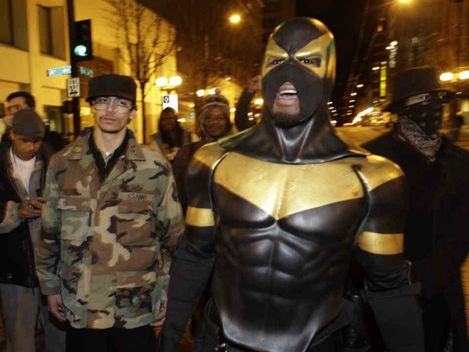
Phoenix Jones
Name: Benjamin Fodor
City: Seattle, Washington
Of all these real life superheroes, Phoenix Jones has probably received the most media attention, especially after being arrested in 2011 for pepper spraying two women. He patrols the area around Seattle and claims that he was motivated to don a mask and cape after his car was broken into and none of the bystanders tried to stop it from happening. Knife wounds, gunshots, street fights—it’s all in a day’s work for Phoenix Jones. The 22-year old is also a professional MMA fighter, which probably comes in handy as he tracks down criminals.Also unlike a lot of other people who pretend to be superheroes, Phoenix’s costume actually has a bullet proof vest and armor plating.
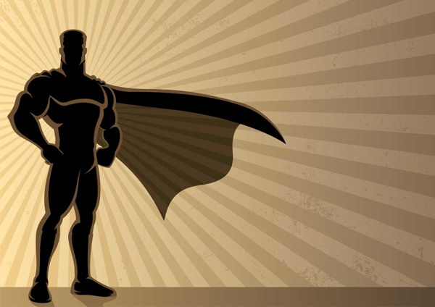

The Flashing Blade
HeroSecret Identity: Secret!
Personal Gotham: South Shields, UK
The Flashing Blade has only been involved in one incident so far, but it was definitely bizarre. A gang armed with chains and knives attacked two detectives in South Shields in 2007. The detectives were unarmed, but out of nowhere a man leaped into the fight, swinging a katana and shouting, “Leave him alone, he’s a police officer!” The sword caught one of the gang members on the arm, and the rest of them turned and ran, according to the report.After the detectives were safe, The Flashing Blade disappeared and was never seen again. The only description the police got was that he was white, in his 40s, and had a mustache. So, be on the lookout.
The Chinese Redbud Woman
Chinese-Redbud
Secret Identity: Secret!
Personal Gotham: Beijing, China
There are plenty of female superheroes that were just as deserving of being on this list as any of the people above, but few superheroes, man or woman, paint such a heartwarming picture as the Chinese Redbud Woman. She has been spotted several times in Beijing wearing a mask and cape and handing out food to homeless people on the streets.
Your Response:
On a separate sheet of paper, answer these two questions.
- Are these people helping their community or are they causing more problems? Use a quote to support your answer. (At least 5 sentences)
- What kind of superhero would you be? Describe your costume and crime fighting stategy. (At least 5 sentences)

